Personal Budget Tracker.

Introduction
In today's fast-paced world, managing personal finances is crucial for achieving financial stability and reaching long-term goals. A Personal Budget Tracker is a tool designed to help individuals monitor their income, expenses, and savings. By providing a clear overview of financial health, users can make informed decisions about their spending habits, identify areas for improvement, and ultimately work towards their financial objectives.

Aim
The primary aim of the Personal Budget Tracker is to empower users to take control of their finances by:
- Tracking income and expenses in real-time.
- Categorizing spending to identify trends and areas for improvement.
- Setting financial goals and monitoring progress.
- Generating reports and visualizations to enhance understanding of financial habits.

Procedure
The development of the Personal Budget Tracker involves several key steps:
- Requirements Gathering: Identify the features and functionalities needed, such as income tracking, expense categorization, goal setting, and reporting.
- Design: Create a user-friendly interface that allows users to easily input data and view their financial status. This may include wireframes and mockups.
- Implementation: Develop the application using a suitable programming language and framework. The application can be web-based, mobile, or desktop.
- Testing: Conduct thorough testing to ensure the application is free of bugs and meets user requirements.
- Deployment: Launch the application for users to access and start tracking their budgets.
- Feedback and Iteration: Gather user feedback to make improvements and add new features over time.

Technologies Used
- Front-end:
  - HTML, CSS, JavaScript
  - React.js (for building user interfaces)
  - Chart.js (for data visualization)
- Back-end:
  - Node.js (JavaScript runtime)
  - Express.js (web framework for Node.js)
  - MongoDB (NoSQL database for storing user data)
  - Mongoose (for MongoDB object modeling)
- Authentication:
  - JSON Web Tokens (JWT) for user authentication
- Deployment:
  - Heroku or Vercel for hosting the application

Architecture
The architecture of the Personal Budget Tracker consists of:
- Client-side (Front-end): A React application that communicates with the back-end API to fetch and display data.
- Server-side (Back-end): An Express server that handles API requests, processes data, and interacts with the MongoDB database.
- Database: MongoDB stores user data, including income, expenses, and categories.

Procedure
- Set Up the Development Environment:
  - Install Node.js and MongoDB.
  - Set up a new React project using Create React App.
  - Set up a new Express project.
- Back-end Development:
  - Create a RESTful API using Express.js.
  - Implement user authentication using JWT.
  - Create models for income, expenses, and users using Mongoose.
  - Set up routes for adding, retrieving, updating, and deleting income and expenses.
- Front-end Development:
  - Build components for user registration, login, and dashboard.
  - Create forms for adding income and expenses.
  - Use Chart.js to visualize income and expense data.
  - Implement state management using React hooks or Context API.
- Testing:
  - Test the application for bugs and ensure all features work as intended.
- Deployment:
  - Deploy the back-end to Heroku and the front-end to Vercel or Netlify.

Sample Code

Back-end (Node.js + Express)
- Setting up the server (server.js):

const express = require('express');
const mongoose = require('mongoose');
const bodyParser = require('body-parser');
const cors = require('cors');
const app = express();
const PORT = process.env.PORT || 5000;

// Middleware
app.use(cors());
app.use(bodyParser.json());

// MongoDB connection
mongoose.connect('mongodb://localhost:27017/budgetTracker', {
useNewUrlParser: true,
useUnifiedTopology: true,
});

// Models
const User = mongoose.model('User ', new mongoose.Schema({
username: String,
password: String,
}));

const Expense = mongoose.model('Expense', new mongoose.Schema({
userId: String,
amount: Number,
category: String,
date: Date,
}));

// Routes
app.post('/api/register', async (req, res) => {
const user = new User(req.body);
await user.save();
res.send(user);
});

app.post('/api/expenses', async (req, res) => {
const expense = new Expense(req.body);
await expense.save();
res.send(expense);
});

app.get('/api/expenses/:userId', async (req, res) => {
const expenses = await Expense.find({ userId: req.params.userId });
res.send(expenses);
});

// Start server
app.listen(PORT, () => {
console.log(`Server is running on port ${PORT}`);
});

Front-end (React)
- Creating a simple dashboard (Dashboard.js):
import React, { useState, useEffect } from 'react';
import axios from 'axios';

const Dashboard = ({ userId }) => {
const [expenses, setExpenses] = useState([]);
const [amount, setAmount] = useState('');
const [category, setCategory] = useState('');

useEffect(() => {
const fetchExpenses = async () => {
const response = await axios.get(`/api/expenses/${userId}`);
setExpenses(response.data);
};
fetchExpenses();
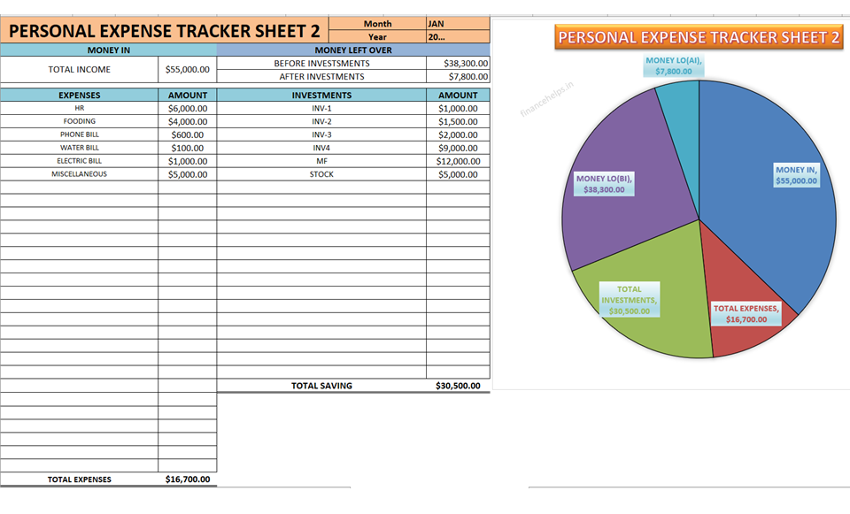

Major Outputs
The major outputs of the Personal Budget Tracker include:
- Income Summary: Total income added by the user.
- Expense Summary: Total expenses categorized by type.
- Balance Calculation: The difference between total income and total expenses.
- Category Breakdown: A detailed view of expenses by category, helping users identify spending patterns.

Total Overview of the Project
The Personal Budget Tracker is a comprehensive tool designed to assist individuals in managing their finances effectively. By allowing users to track their income and expenses, set financial goals, and generate insightful reports, the application promotes better financial decision-making. The project can be expanded with additional features such as:
- Integration with bank accounts for automatic transaction tracking.
- Mobile app development for on-the-go access.
- Advanced analytics and visualizations (charts, graphs).
- User authentication and data security measures.
Overall, the Personal Budget Tracker serves as a valuable resource for anyone looking to improve their financial literacy and achieve their financial goals.

